LaGrange County 4-H Horse & Pony Club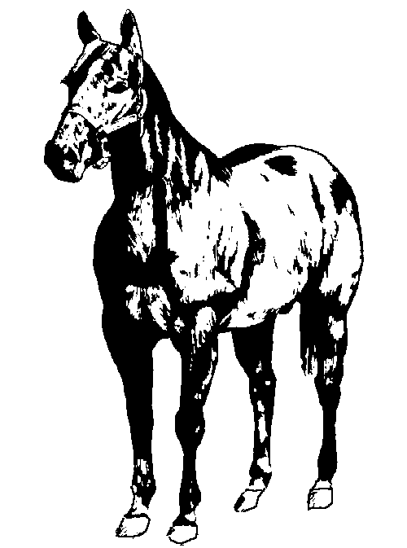
2023 Sponsor Drive

The annual sponsorship drive is once again underway. This year we are again asking for donations to help offset some of our expenses. The horse & pony club has approximately sixty-five families involved in the program. This gives us between ninety to one hundred youth to help educate and learn how to have responsible fun with their horses.

We will be putting on open horse shows, providing special clinics, and heading up numerous riding meetings again this year. These events all help to educate and keep our kids active in a productive program.

We are asking businesses and individuals to help us with the costs involved in keeping our program strong and growing. Below you will see the areas needing support. Please fill out the form provided, keeping the top portion for your records and returning the lower portion with your payment to the 4-her that has approached you. We will again be announcing our sponsors throughout our open horse shows. This sponsor drive has been very successful in the past and with your help, our club will continue to grow and many families will learn to be responsible horse owners along with learning by working hard and having fun at the same time. Please feel free to visit the fair grounds and see the improvements we have made with generous sponsors like you and the hard work of all our club members and their families.

If you have any questions regarding the sponsor drive, feel free to contact:
Amber Hochstetler (260)585-4272 or Linda Burkhead (260)463-1053
Checks can be mailed to PO Box 145, LaGrange, IN 46761
Checks should be made out to: LaGrange County Horse and Pony

Amount Paid: $__________ Date Paid: _________________ 4-Her Signature:___________________________
- - - - - - - - - - - - - - - - - - - - - - - - - - - - - - - - - - - - - - - - - - - - - - - - - - - - - - - - - - - - - - - - - - - - - - - - - - - - - - - - - - - -
Name ____________________________________________ Phone #_______________________
Address __________________________________________
City, State & Zip ___________________________________ 4-Her ________________________
Speed Shows
____$200
____$100
____$50
____$25
____Other
Pleasure Shows
____$200
____$100
____$50
____$25
____Other
General Fund
____$200
____$100
____$50
____$25
____Other

2’x3’ white sign on fence with Name, Address, & Phone Number lettered with color selected below.
Circle color choice:
Blue Green Black Red
____$375(New Sign)
____$300(Existing Sign)

